Numerical Study of Effective Negative Viscosity in Ferrofluids under Oscillating Magnetic Fields
A stable colloidal suspension of ferrofluid is formed when magnetic nanoparticles (MNPs) (diameter < 15 nm) are dispersed in a non-magnetic carrier liquid [1]. The nanoparticles are coated with surfactants to prevent agglomeration. When exposed to an external magnetic field, the magnetic moments of the MNPs align with the field through either Neel relaxation $\left(τ_{N}\right)$, where the magnetic moment rotates within a fixed particle, or Brownian relaxation $\left(τ_{B}\right)$, where the entire particle physically rotates within the fluid to align with the field. Under a static magnetic field, if $τ_{B}$ < $τ_{N}$, the rotation of particles is resisted by the fluid, leading to an increase in viscosity, known as rotational viscosity. However, under oscillating magnetic field, the viscosity has a non-monotonic behaviour due to the phase lag between the magnetic moment and the applied field. This behaviour is governed by the non-dimensional frequency parameter $κτ_{B}$, where $κ$ is the frequency of the external field. For $κτ_{B}<1$, rotational viscosity increases with magnetic field strength. And, for $κτ_{B}>1$, rotational viscosity decreases with the strength of the magnetic field, a regime known as "negative viscosity" [2], where part of the magnetic energy is converted into kinetic energy, resulting in accelerating the fluid. This negative-viscosity regime enables various applications, such as pumping and mixing of ferrofluids. For instance, fluid pumping has been demonstrated using both spatially uniform sinusoidal time-varying magnetic fields [3] and spatially traveling magnetic fields [4] applied transverse to the duct axis.
In this work, we investigate the pumping and mixing effects arising from negative viscosity by numerically solving the governing equations using a hybrid Lattice Boltzmann Method (LBM). In this approach, the translational momentum equation is solved using LBM, while the remaining governing equations are addressed via a combination of finite difference and finite volume methods. The study is aimed to understand whether reduced viscosity can lead to valveless micro pumping for microfluidic systems and targeted drug delivery in complex vascular networks. While experimental and theoretical evidence of Rosensweig instability in thicker films are quite known now, this work will investigate the influence of negative viscosity on the stability of ferrofluid thin films, particularly its role in amplifying hydrodynamic instabilities. This will aid in fabrication of magnetically tunable soft-matter systems.
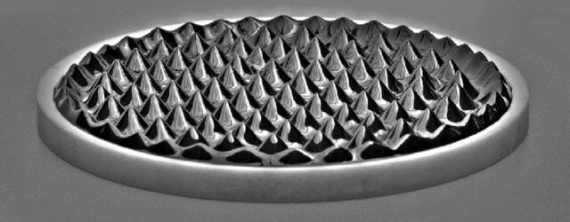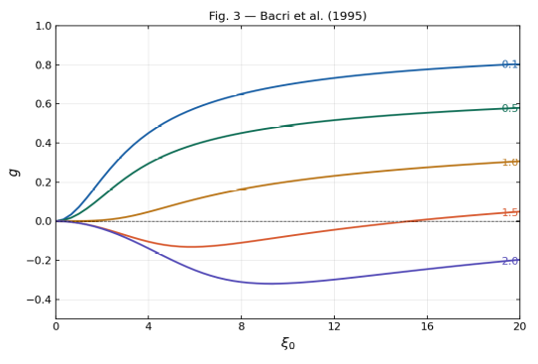
Fig:1(a) Rosensweig instability in thicker films (b) Theoretical variations of change in viscosity with oscillation showing negative values [2]
Governing equations:
The equation of motion for incompressible, isothermal ferrofluid flows assuming monodisperse, spherical, rigid, and spatially uniform distribution of magnetic particles are given by Eq. (1) and Eq. (2).
$∇.u=0$ and $∇.ω=0$ (1)
$ρ\frac{Du}{Dt}=-∇p+μ_{o}M∙∇H+ζ\left(∇×ω\right)+\left(λ+η-ζ\right)∇\left(∇∙u\right)+\left(η+ζ\right)∇^{2}u$ (2)
Where $ρ$ is the macroscopic density of fluid, $u$ and $ω$ are the translational velocity of fluid and spin velocity of the particle, and $p$ is the pressure. $λ$, $η$, and $ζ$ are bulk, shear and vortex viscosities. Furthermore, $H$ and $M$ are external magnetic field intensity and magnetization of the ferrofluid. The internal angular momentum equation obtained from the macroscopic angular momentum conservation equation for isotropic spheric is as follows,
$ρI\frac{Dω}{Dt}=μ_{o}M×H+ 2ζ\left(∇×u-2ω\right)+\left(λ^{'}+η^{'}\right)∇\left(∇∙ω\right)+η^{'}∇^{2}ω$. (3)
Where $I$ is the density of moment of inertia of magnetic nanoparticles, $λ^{'}$ and $η^{'}$ are the bulk and shear spin viscosities.
Since under an alternating magnetic field, magnetization of fluid does not change instantaneously, the magnetization relaxation equation is given by Eq. (4).
$\frac{DM}{Dt}+u∙∇M=ω×M-\frac{1}{τ}\left(M-M_{eq}\right)$ (4)
$M_{eq}$ is the equilibrium magnetization and $τ$ is the effective relaxation time calculated by $\frac{1}{τ}=\frac{1}{τ_{N}}+\frac{1}{τ_{B}}$.
The Maxwell equations for the non-conducting ferrofluids namely Gauss law and Ampere law of magnetism are given by Eq. (5).
$∇∙B=0, ∇×H=0$ (5)
Where $B$ magnetic induction field, and $B=μ_{o}\left(H+M\right)$. From the Ampere law of magnetism, $H=-∇φ$ where $φ$ is a scalar magnetic potential. By substituting the expressions for $H$ and $M$ in Gauss law, the following equation is obtained.
$∇^{2}φ=∇∙M$ (6)
Numerical Methods:
Eq. (1) and Eq. (2) are solved by the lattice Boltzmann method with multiple-time relaxation collision operator (MRT-LBM) given by the Eq. (7).
$f_{i}\left(x+e_{i}δt, t+δt\right)-f_{i}\left(x, t\right)=-{\left(M^{-1}ΛM\right)}_{ij}\left(f_{j}\left(x, t\right)-f_{j}^{eq}\left(x, t\right)\right)+δtF_{net,i}^{'}$ (7)
Where $f_{i}$, $f_{i}^{eq}$, and $F_{net,i}^{'}$ are the density, equilibrium distributions, and net force acting on particles in lattice space corresponding to the microscopic velocity, $e_{i}$. $M$ is an orthogonal transformation matrix that transforms distributions into moment space since, in MRT-LBM, collision occurs in moment space. Moreover, $M^{-1}$ is an inverse transformation matrix that transforms back moments $\left(m\right)$ to lattice space. The macroscopic density and translational velocities are calculated by, $ρ=\sum_{i}{f_{i}}$, $ρu=\sum_{i}{f_{i}}e_{i}+\frac{δ_{t}}{2}F_{net}$. The Eq. (3), Eq. (4), can be discretized using finite difference method and time integrated using the RK-4th order method. Eq. (6) is discretized using second-order central finite volume scheme and the resultant system of linear equations are solved by the alternate direction implicit method.
Work Plan:
Task | Objective | Expected Outcome
Task 1: Validation of Hydrodynamic Solver | Validate the MRT-LBM hydrodynamic solver against the analytical Poiseuille flow solution and benchmark results available in the literature. | Establish the accuracy and stability of the numerical framework for ferrohydrodynamic simulations.
Task 2: Magnetically Driven Pumping and Mixing | Investigate flow generation in the absence of a pressure gradient by incorporating spatial magnetic field gradients (∇H) into the forcing term. Particular emphasis will be placed on asymmetric oscillating magnetic fields and their ability to induce net fluid transport and enhanced mixing. | Demonstrate Kelvin-force-driven valveless pumping and identify conditions leading to directional transport, with potential applications in targeted drug delivery and microfluidics.
Task 3: Temperature Effects on Negative Viscosity | Examine the influence of temperature on negative-viscosity-induced phenomena. Subsequently, study the effect of temperature gradients at fluid–solid interfaces, including spatial variations in viscosity and thermally induced changes in flow behavior. | Quantify the interplay between thermal effects, viscosity modulation, and ferrofluid hydrodynamics.
Task 4: Flow Through Complex Geometries | Analyze the effect of negative viscosity on ferrofluid flow through obstacles, constrictions, and bends. Investigate changes in flow separation, pressure losses, skin friction, and form drag. | Develop insights into drag reduction/amplification mechanisms and transport enhancement in complex microfluidic networks.
Task 5: Ferrofluid Thin-Film Instabilities | Study thin ferrofluid films subjected to oscillating magnetic fields and investigate the role of negative viscosity in the onset and growth of hydrodynamic instabilities, film deformation, and breakup dynamics. | Identify instability regimes and assess their potential for pattern formation, enhanced mixing, adaptive surfaces, and controlled droplet generation.
References:
- Papell, S. S. (1965). Low viscosity magnetic fluid obtained by the colloidal suspension of magnetic particles Patent (No. Patent Number: US-PATENT-3,215,572).
- Bacri, J. C., Perzynski, R., Shliomis, M. I., & Burde, G. I. (1995). “Negative-viscosity” effect in a magnetic fluid. Physical review letters, 75(11), 2128.
- Zahn, M., & Greer, D. R. (1995). Ferrohydrodynamic pumping in spatially uniform sinusoidally time-varying magnetic fields. Journal of magnetism and Magnetic materials, 149(1-2), 165-173.
- Mao, L., & Koser, H. (2005). Ferrohydrodynamic pumping in spatially traveling sinusoidally time-varying magnetic fields. Journal of magnetism and Magnetic materials, 289, 199-202.

